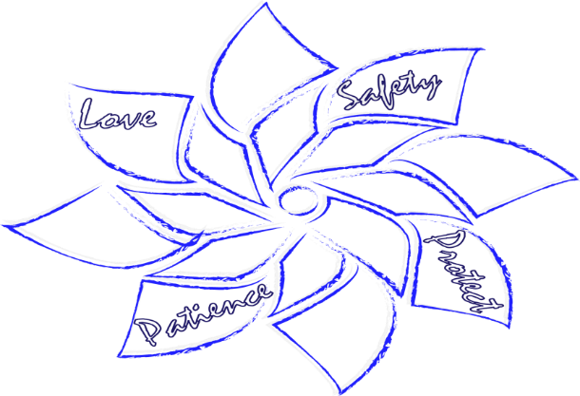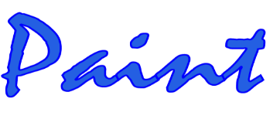
“Pinwheel gardens” are visual reminders that we all play a role in ensuring happy and healthy
childhoods for all children everywhere.
Raising Awareness for the Prevention of Child Abuse

To order Pinwheels, Signs, or Car Magnets
Pinwheels $2 Minimum order of 10, but we recommend 25 for a pinwheel garden

PHB Yard Sign $15 Car Magnets $5
Package $40 Includes 10 pinwheels, 1 double sided sign and 1 car magnet

Please complete the form below and email it to robin@preventchildabusehc.org. The deadline is March 25, 2022. You may also call or text Robin Jones 678-697-8500.
Contact Name: Phone: . Email:
Agency/ Business . Address: City: Zip: . Pinwheels: quantity ($2 each) Signs: quantity ($15 each)
Car Magnets: quantity ($5 each) Package: quantity ($40 each) Total Payment: $ .

Make your checks payable to Prevent Child Abuse Henry. The orders will be available the last week of March. For credit card payment please contact Robin Jones at 678-697-8500. We will contact you for pick- up/ delivery information.

