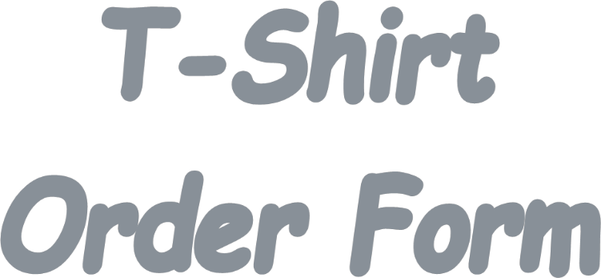
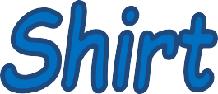
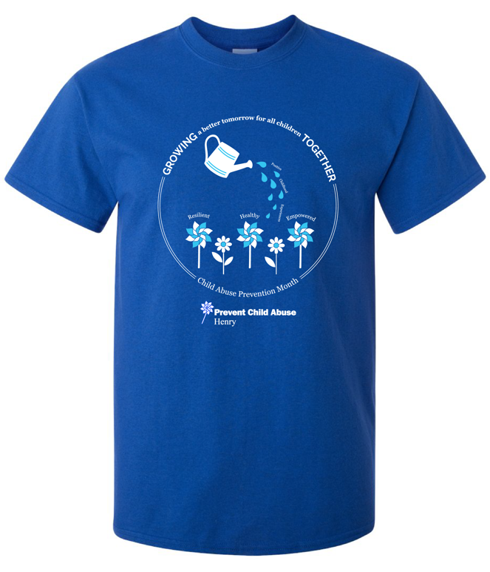

The Official 2022 Paint Henry Blue T-Shirt

Name:
Phone:_______________________ _____
Email:___________________________________

Please indicate how many of each size (cost $15.00 for sizes Adult S– Adult XL and $17.00 for sizes Adult 2XL – Adult 3XL) All proceeds go to Prevent Child Abuse Henry

Adult S:
Adult M:

Adult L: Adult XL:

Adult 2XL: ______
Adult 3XL: _____

Total: $

Make checks payable to: Prevent Child Abuse Henry
You may also pay by credit card

Contact Robin Jones at 678-697-8500 to place your order or email to robin@preventchildabusehc.org.

